**VISVESVARAYA TECHNOLOGICAL UNIVERSITY**

**“Jnana Sangama”, Belgaum -590014, Karnataka.**



**PROJECT WORK-1 REPORT**

**on**

**“Music Artist HHH’s Page”**

***Submitted by***

**Harsh Shankar Rao(1BM18CS032)**

**Harshavardhana K(1BM15CS035)**

**Harshit Hiremath(1BM15CS036)**

***Under the Guidance of***

|  |  |
| --- | --- |
| **Mrs. Namratha G**  **Assistant Professor, BMSCE** |  |

***in partial fulfillment for the award of the degree of***

**BACHELOR OF ENGINEERING**

***in***

**COMPUTER SCIENCE AND ENGINEERING**



**B.M.S. COLLEGE OF ENGINEERING**

**(Autonomous Institution under VTU)**

**BENGALURU-560019**

**DEC 2019**

**B. M. S. College of Engineering,**

**Bull Temple Road, Bangalore 560019**

(Affiliated To Visvesvaraya Technological University, Belgaum)

**Department of Computer Science and Engineering**



**CERTIFICATE**

This is to certify that the project work entitled “**Music Artist HHH’s Page**” carried out by **HARSH SHANKAR RAO (1BM18CS032), HARSHAVARDHANA K (1BM18CS035), and HARSHIT HIREMATH (1BM18CS036**) who are bonafide students of **B. M. S. College of Engineering.** It is in partial fulfillment for the award of **Bachelor of Engineering in Computer Science and Engineering** of the Visveswaraiah Technological University, Belgaum during the year 2019. The project report has been approved as it satisfies the academic requirements in respect of **Project Work-1 (19CS3PWPW1)** work prescribed for the said degree.

Signature of the Guide                 Signature of the HOD

Mrs. Namratha G Dr. Umadevi V

Assistant Professor Prof & Head of Dept of CSE

BMSCE, Bengaluru BMSCE, Bengaluru

External Viva

Name of the Examiner                                                                                       Signature with date

1._____________________________ ________________________

2. _____________________________ _________________________

**B.M.S. College of EngineerinG**

**DEPARTMENT OF COMPUTER SCIENCE AND ENGINEERING**



***DECALARATION***

We Harsh Shankar Rao (1BM18CS032), Harshavardhana K (1BM15CS035), and Harshit Hiremath (1BM18CS036), students of 3rd Semester, B.E, Department of Computer Science and Engineering, BMS College of Engineering, Bangalore, hereby declare that, this Web Programmingwork entitled "**Music Artist HHH’s Page**" has been carried out by us under the guidance of Prof. Namratha G, Assistant Professor, Department of CSE, BMS College of Engineering, Bangalore during the academic semester Aug-Dec 2019.

We also declare that to the best of our knowledge and belief, the development reported here is not from part of any other report by any other students.

**Signature**

Harsh Shankar Rao (1BM18CS032) :

Harshavardhana K (1BM15CS035) :

Harshit Hiremath (1BM18CS036) :

**TABLE OF CONTENTS**

|  |  |  |
| --- | --- | --- |
| **CHAPTER NO.** | **TITLE** | **PAGE NO.** |
| 1 | **Introduction** | 1 |
| 1.1 | Overview | 5 |
| 1.2 | Motivation | 5 |
| 2 | **Software Requirement Specification** | 6 |
| 2.1 | Hardware Requirements | 6 |
| 2.2 | Software Requirements | 6 |
| 3 | **User Interface Design** | 7 |
| 3.1 | Home Page | 7 |
| 3.2 | Login screen | 9 |
| 3.3 | Sign Up Page and Form Validations used | 12 |

1. **INTRODUCTION**
   1. **Overview**

Every artist has his/her own unique style and approach to their brand image. And every other artist has his/her unique set of fans and followers who are always willing to know what the artist is upto and what is his/her latest work.

Our project, “Music Artist HHH’s Page”, is focused on solving this want of knowing your favorite artist’s updates.

The look, feel, appeal, and the UI/UX of the first page that loads up on the user’s display is very important to create a positive image of the artist in the follower’s mind. Keeping this in mind, we have developed a beautiful looking website that does all the jobs mentioned above, and also helps the artist to have a medium in which it is very easy to convey some message, share new music, and also create a simple and easy to find portal for selling the artist’s event’s ticket and his/her merchandise.

* 1. **Motivation**

Our major motivations came when we observed the following flaws in the brands of modern artists:

1. Lack of modern medium to share new work with fans and followers, in a legal approach.
2. Lack of having a database of true fans and followers, whose constant interest in artist’s work would motivate the artist to do more.
3. Lack of having artist’s own website, in which the artist can sell his/her event’s tickets and merchandise, where no third-party is involved.
4. **Software Requirements**
   1. Hardware Requirements:

* A PC with the following or greater specifications:
  + Intel Core i3 (4th gen or higher)
  + 2 GB RAM
  + 100 GB Hard Drive
* A stable internet connection (1Mbps or higher).
  1. Software Requirements:
* Operating system : Windows XP(SP2/SP3), Vista, 7, 8/8.1, 10

Ubuntu 14+

* Technologies : HTML, CSS, JavaScript
* IDE Used for editing : Vim / Brackets / Atom / VS Code

1. **User Interface Design**
   1. **Homepage**

The homepage is the first page the user usually arrives at. Hence this page has to be made attractive, be sensibly relaxing, and entertaining.

Since the website is mainly for the middle ages we have made it a

Theme-based website which is in dark mode featuring two primary colors (Black and Yellow) which is intended to save more power and to make it look attractive

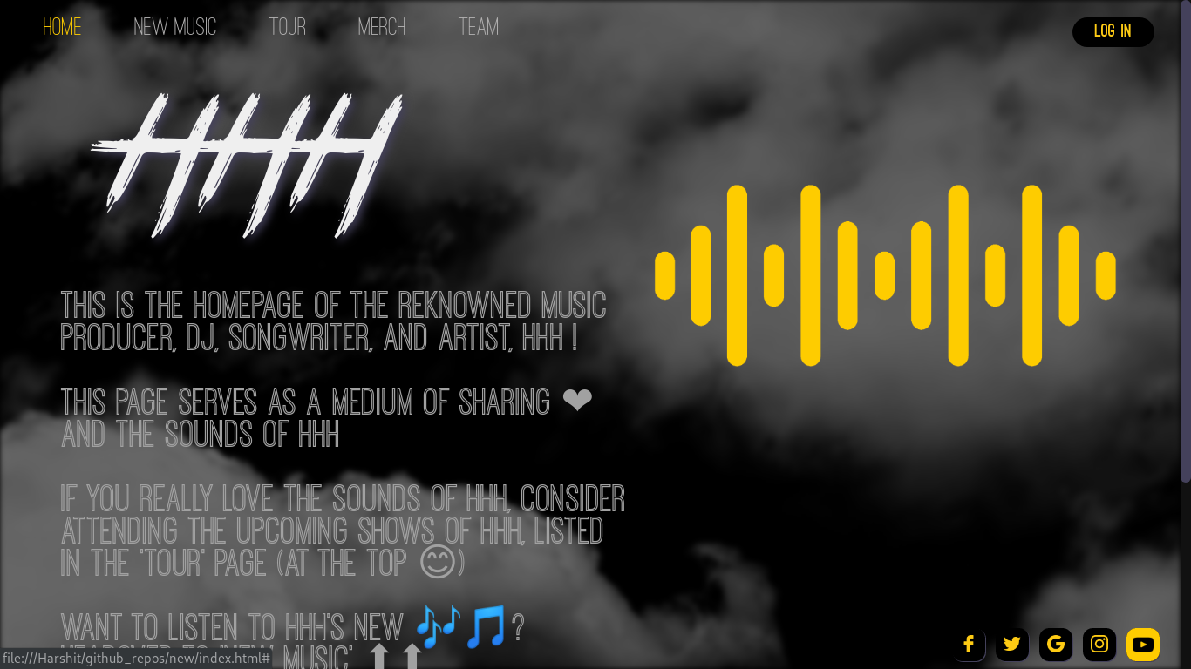

As the intention of the moment is to make the look and feel of the first page be good, have an efficient code to be practically feasible and efficient enough to be used in real-life where the traffic is unpredictable, and can go haywire any moment, the following steps were taken get the above shown picture as the output.

The first thing that is noticed is the moving cloud background.

The approach to this was as follows:

1. Create a background container which contained the main super ultra-wide cloud image.
2. Animate it to move the cloud image continuously in a loop, (an infinite loop).
3. Add blur to the container a little.
4. Add the header links.
   1. **Login Page**

This page allows the fans using the website to login with the help of username and password. Logging in gives them privileges to extra features like creating a playlist of their interests and buying merchandise of their favorite artists. The website will also update the logged in users about the artists they follow and if there are any tours in their city they will be notified.

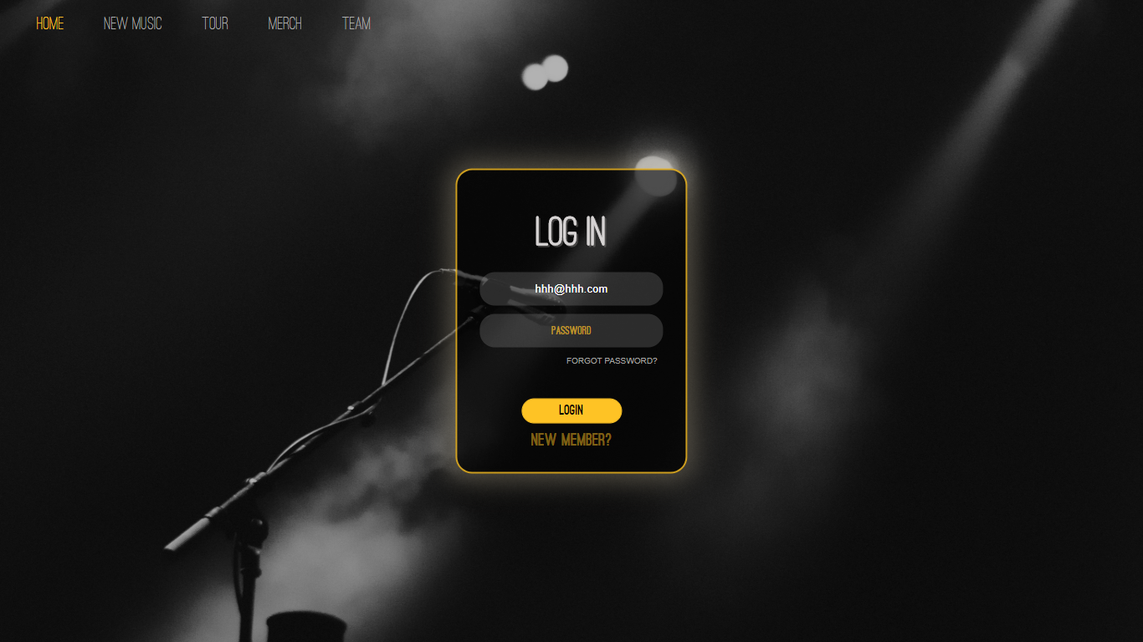

To make the user feel the website is legitimate, and create a connection with the webpage, we have added a breathing glow effect to the login form box which glows with a high intensity after every 1.5 seconds. This will make the user feel more active and will hence make the best use of the website.

The following image shows the page when the form glow is at the 100% opacity.

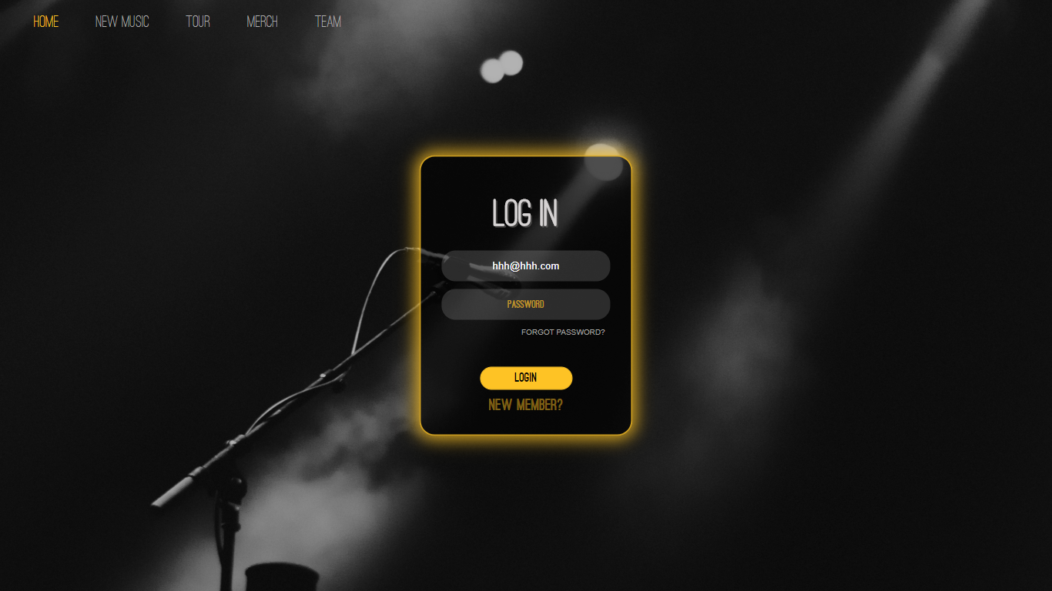

As you can see in the above picture, the glow of the box is completely glowing.

When the user enters valid username and password, the login page will take the user back to the home page, but now the “Log In” button would be changed to “Log Out” due to obvious reasons.

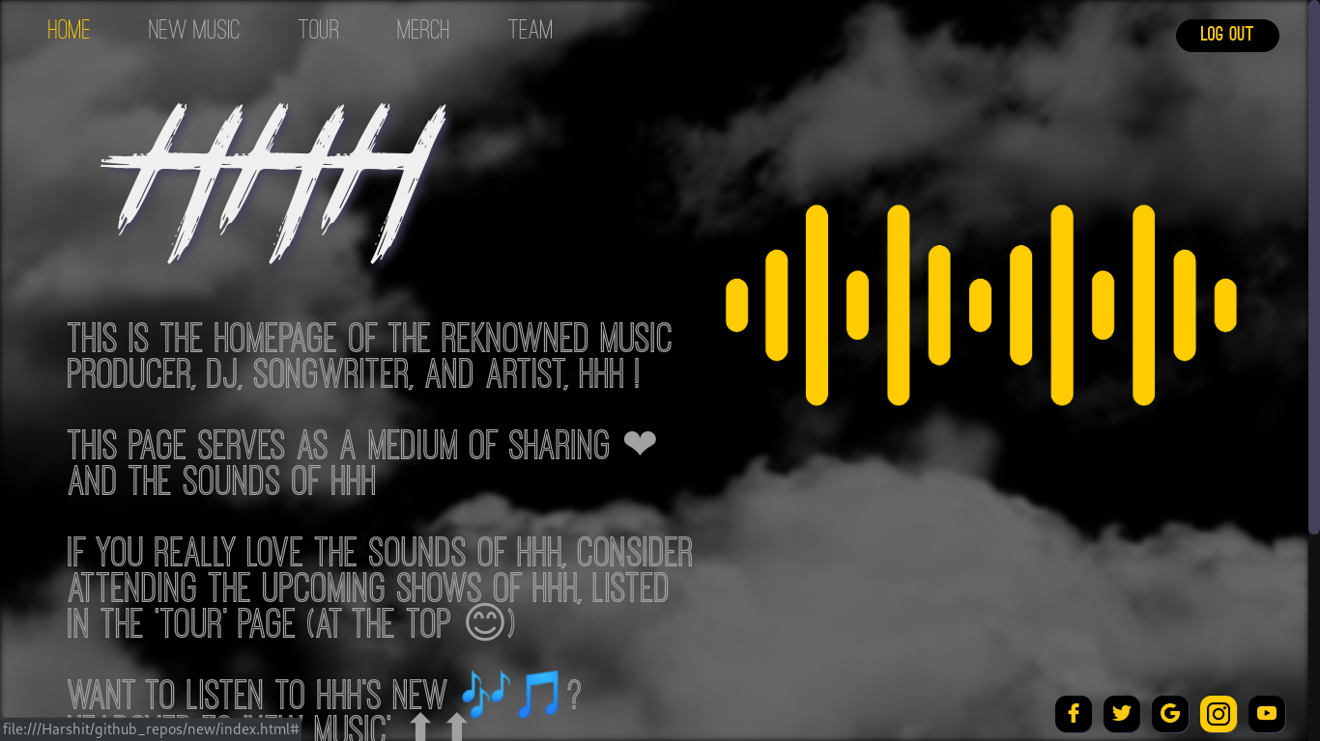

As you can see in the above image, after successfully logging in, the website takes the user to the Homepage, but now, the “Log In” is changed to “Log Out”.

* 1. **Sign Up Page and Form Validation used**

This page allows the fans to register for the website and create his/her own profile using which they can enjoy the privileges on our website. The user can create his/her own profile just by entering their username, e-mail id, phone numbers and by entering a suitable password for secure access to the website.

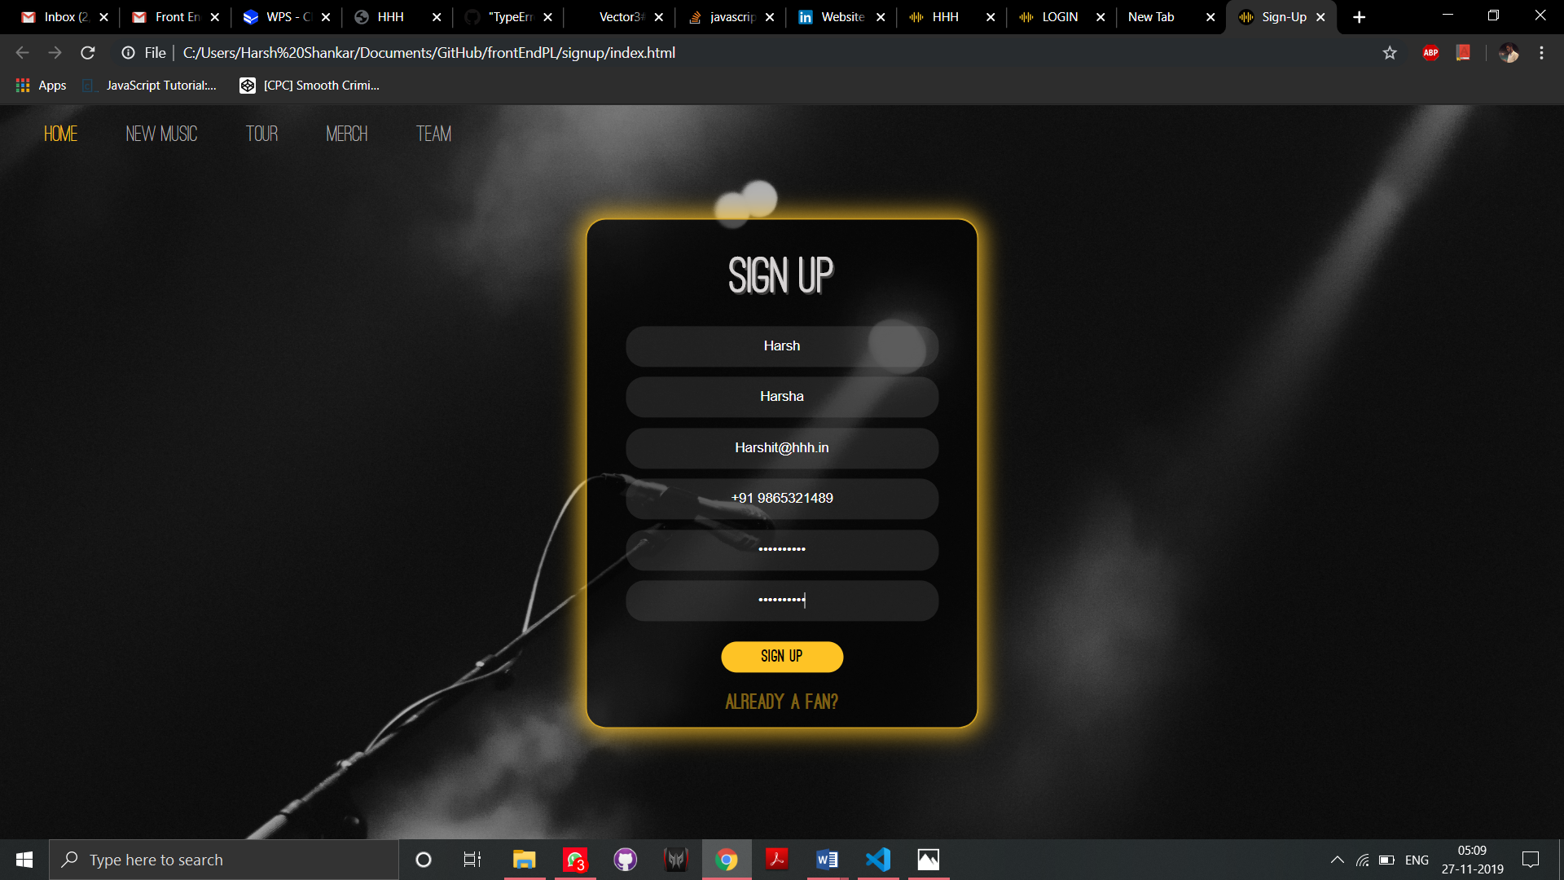

The above image shows the sign up page which again has a glowing box like the one in Log in page. The box contains many forms, which have to filled correctly to register.

The input values are locally validated using JavaScript. The following are the form validations used:

1. No First name or Last name filled:

When the first name or last name are not filled, the browser notifies the user.

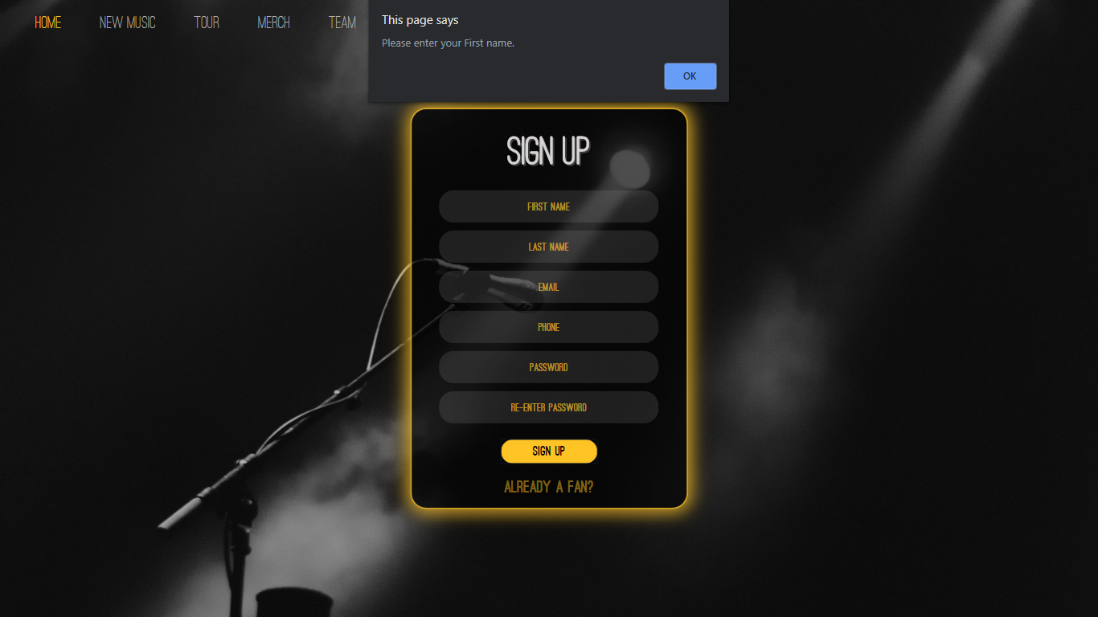

In the picture shown above, we can see that the error message “Please Enter you first name” appears. After ‘OK’ is pressed, the cursor moves to the First name box.

The same applies to the last name also.

1. When no email is typed:

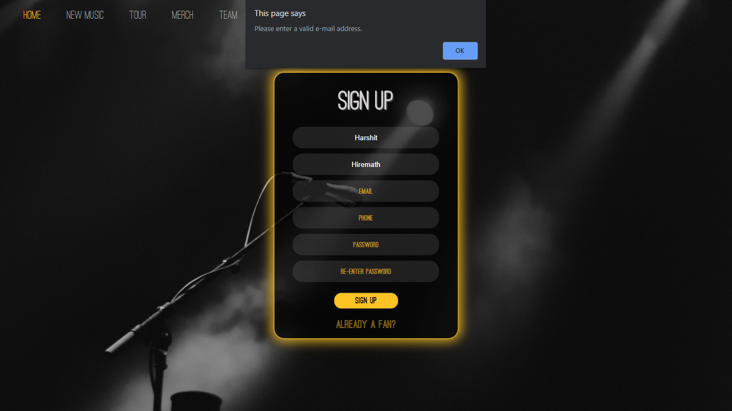

As you can see in the above diagram the “Please enter a valid Email address” error message pop-up.

After “OK” is pressed, the email form is highlighted.

1. When no password is input in the password form:

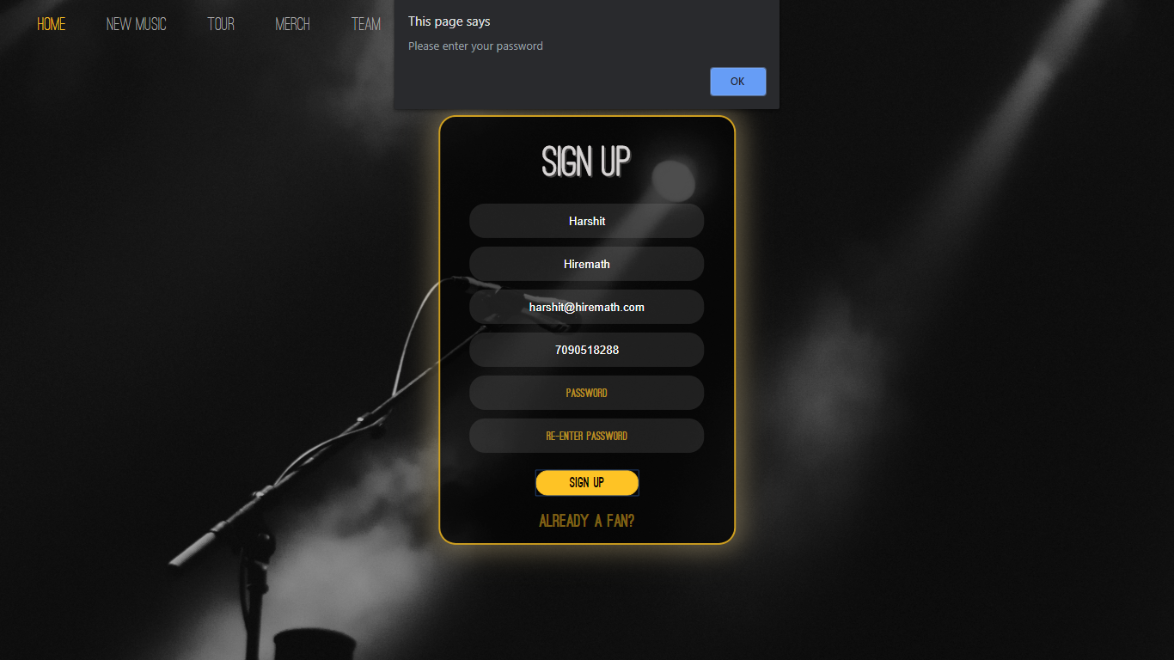

When no password is input, the error message “Please enter your password” appears. This means the user has left the password field blank.

After “OK” is pressed, the password form is highlighted.

1. Small Password input:

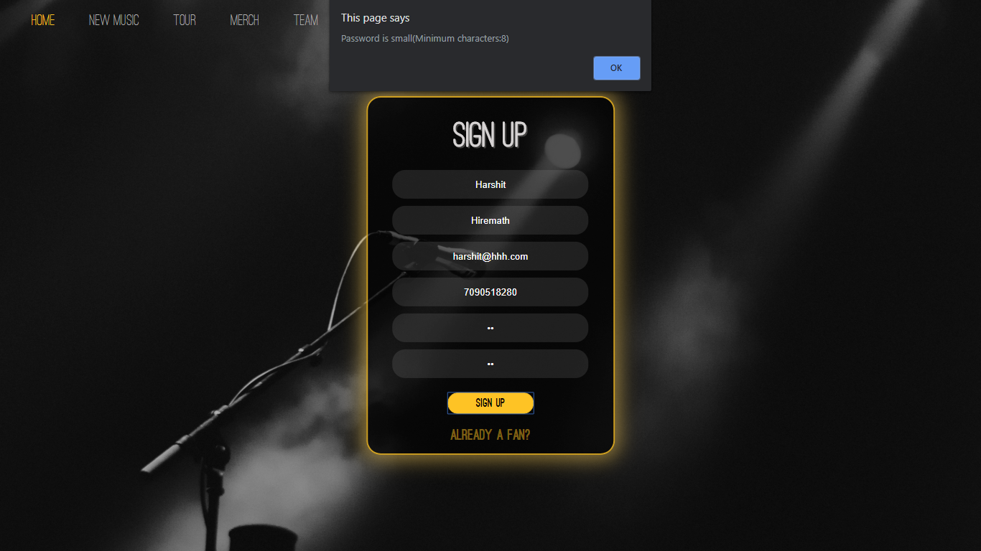

When the user registers with small passwords, it becomes really easy to crack the password.

When the user enters passwords of size less than 8, an error message “Password is small(Minimum characters:8)” is shown.

When the user clicks on “OK”, the passwords form is highlighted.

1. Passwords donot match:

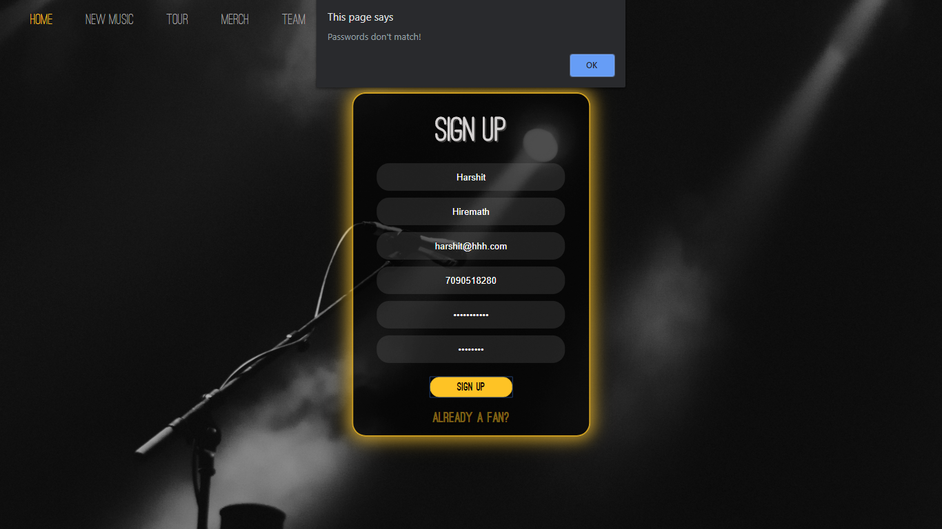

Typos are really common in modern lifestyle, and when the user registers with the password that has type in it, the user can virtually never log in with the correct password as he/she can’t simulate the same typo again. Hence, it typos should be removed.

This is achieved by having 2 password forms. When the passwords are longer than 8 characters, the password is accepted; else, not.

As you can see in the above image, an error message “Passwords don’t match” appears, and the password form is highlighted when “OK” is pressed.

When all the forms are correctly input and all the forms are validated, the webpages take the input & push it to the server.

After successful logging in, the webpage takes the user back to the homepage, but now the “Log In” button us changed to “Log Out”.

The signed in user page of the home page looks like the following:



* 1. **Teampage:**

Teampage is used to show the details about the developers of the page.

It looks like the following image when logged in.

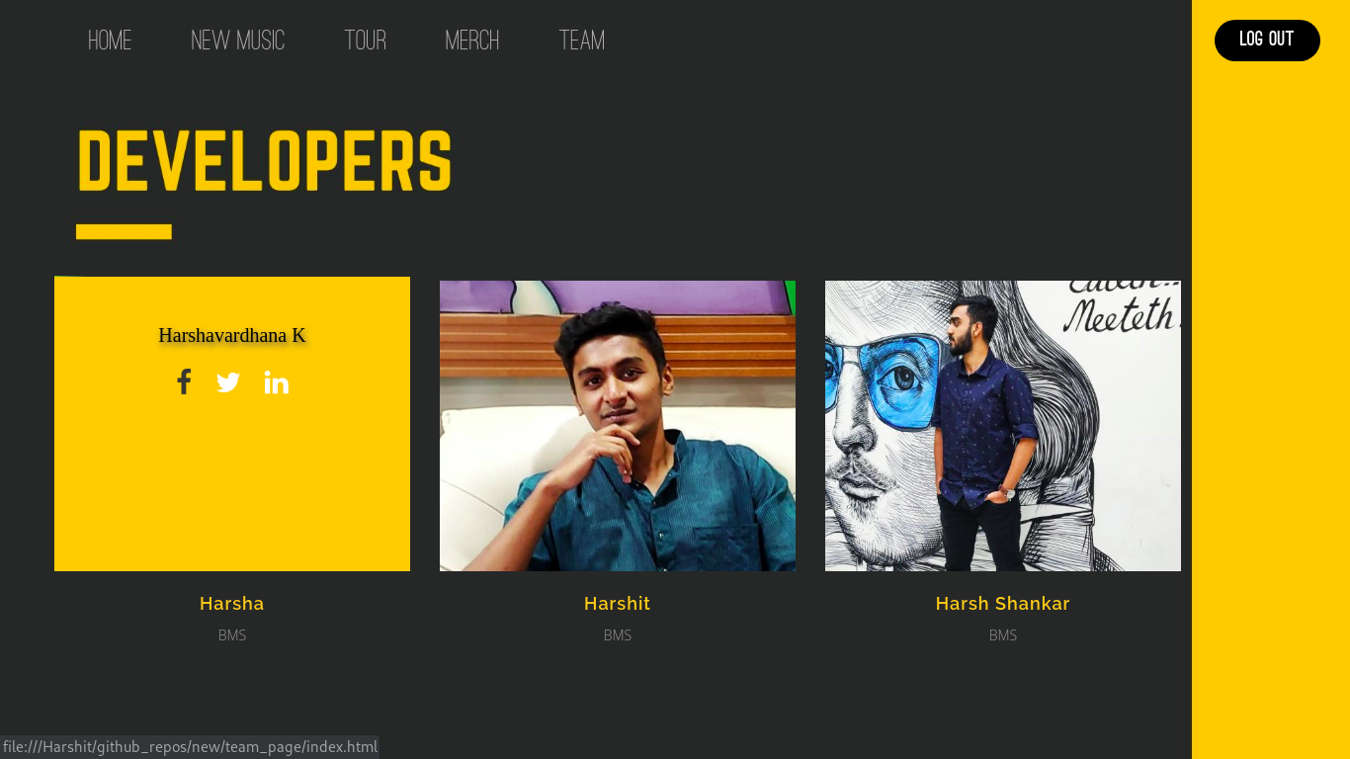

As you can see in the above image, the developer information appears over the image. This added to the theme of the project, makes it look very interesting.

When logged out, it looks like the following:

